

**THE** **PROJECT REPORT**

On

**“Medical Image Enhancement and Malignancy Segmentation System (MIEMSS)”**

**Submitted to**

**KIIT Deemed to be University**

**In Partial Fulfilment of the Requirement for the Award of**

**BACHELOR’S DEGREE IN**

**COMPUTER SCIENCE & ENGINEERING**

**BY**

**GROUP**

**Sayandeep Kanrar 22053357**

**Soham Dutta 22052064**

**UNDER THE GUIDANCE OF**

**Vikas Hassija**



**SCHOOL OF COMPUTER ENGINEERING**

**KALINGA INSTITUTE OF INDUSTRIAL TECHNOLOGY**

**BHUBANESWAR, ODISHA - 751024**

**April 2025**

KIIT Deemed to be University

School of Computer Engineering

Bhubaneswar, ODISHA 751024



CERTIFICATE

**This is certify that the project entitled**

**“Medical Image Enhancement and Malignancy Segmentation System (MIEMSS)”**

**Submitted By**

**Sayandeep Kanrar 22053357**

**Soham Dutta 22052064**

is a record of bonafide work carried out by them, in the partial fulfilment of the requirement for the award of Degree of Bachelor of Engineering (Computer Sci-ence & Engineering OR Information Technology) at KIIT Deemed to be university, Bhubaneswar. This work is done during the year 2024-2025, under our guidance.

Date: 09/04/2025

Project Guide Vikas hasija

**Acknowledgements**

We are profoundly grateful to **Vikas Hassija** of **KIIT** for his expert guidance and continuous encouragement throughout to see that this project meets its target since its commencement to its completion.

Sayandeep Kanrar (22053357)

Soham Dutta (22052064)

**ABSTRACT**

The Medical Image Enhancement and Malignancy Segmentation System (MIEMSS) project aims to enhance and segment anomalies in medical X-ray images using computer vision and machine learning techniques. The system processes grayscale X-ray images, applies denoising, and utilizes algorithms such as HOG and Isolation Forest for malignancy detection and segmentation.

The MIEMSS project demonstrates the use of AI for efficient medical image analysis and provides a foundation for developing computer-aided diagnostic tools to support radiologists in detecting abnormalities faster and more accurately.

**Keywords**: Medical Image Analysis, X-ray, LLM, Image Enhancement, Malignancy Segmentation, Computer Vision, Machine Learning, HOG, Isolation Forest



**Contents**

|  |  |  |  |  |
| --- | --- | --- | --- | --- |
| 1 | Introduction | | | 1 |
| 2 | Basic Concepts/ Literature Review | | | 2 |
|  | 2.1 | Image Denoising | | 2 |
|  | 2.2 | HOG | | 2 |
|  | 2.3 | Isolation Forest | | 2 |
|  | 2.4 | Python libraries | | 2 |
| 3 | Problem Statement / Requirement Specifications | | | 3 |
|  | 3.1 | Project Planning | | 3 |
|  | 3.2 | Project Analysis (SRS) | | 3 |
|  | 3.3 | System Design | | 3 |
|  |  | 3.3.1 | Design Constraints | 3 |
|  |  | 3.3.2 | System Architecture (UML) / Block Diagram | 3 |
| 4 | Implementation | | | 5 |
|  | 4.1 | Methodology / Proposal | | 5 |
|  | 4.2 | Testing / Verification Plan | | 6 |
|  | 4.3 | Result Analysis / Screenshots | | 7 |
|  | 4.4 | Quality Assurance | | 7 |
| 5 | Standard Adopted | | | 8 |
|  | 5.1 | Design Standards | | 8 |
|  | 5.2 | Coding Standards | | 8 |
|  | 5.3 | Testing Standards | | 8 |
| 6 | Conclusion and Future Scope | | | 9 |
|  | 6.1 | Conclusion | | 9 |
|  | 6.2 | Future Scope | | 9 |
| References | | | | 10 |
| Individual Contribution | | | | 11 |
| Plagiarism Report | | | | 13 |



**List of Figures**

* Model Architecture - 1
* Original (with noise) image - 5
* Denoising image - 5
* Heatmap image - 4
* PSNR improvement_1 image - 5
* PSNR improvement_2 image - 4

*The Medical Image Enhancement and Malignancy Segmentation System (MIEMSS)* 



Chapter 1

Introduction

This project addresses the critical need for efficient and accurate analysis of

medical X-ray images. Current methods can be time-consuming and may lead to overlooking subtle anomalies. The Medical Image Enhancement and Malignancy Segmentation System (MIEMSS) aims to provide a solution by automating the enhancement and segmentation of potentially malignant regions in X-ray images. This system utilizes computer vision and machine learning techniques to denoise images and detect abnormalities, which can aid radiologists in making faster and more accurate diagnoses. The report is structured to provide an overview of the project, detail the system's design and implementation, and discuss the results and potential future applications.

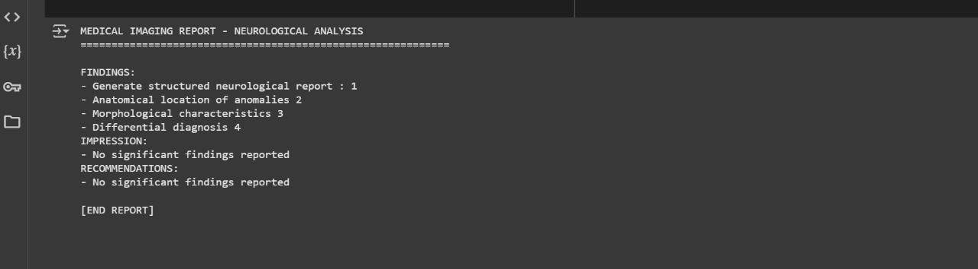

Figure 1.1: Final Output



*School of Computer Engineering, KIIT, BBSR* 1

*NA The Medical Image Enhancement and Malignancy Segmentation System (MIEMSS)*



Chapter 2

Basic Concepts/ Literature Review

This section outlines the core concepts, tools, and techniques employed in the MIEMSS project.

**2.1 Image Denoising**

Image denoising is a crucial preprocessing step to enhance the quality of X-ray images. The MIEMSS project utilizes the Fast Non-Local Means Denoising algorithm to reduce noise while preserving important image features.

**2.2 Histogram of Oriented Gradients (HOG)**

HOG features are used to extract relevant information from the denoised images. HOG is a feature descriptor widely used in computer vision for object detection.

**2.3 Isolation Forest**

The Isolation Forest algorithm is employed for anomaly detection. It identifies outlier pixels in the images that may represent malignant regions.

**2.4 Python Libraries**

The project is developed using Python and several key libraries:

* **OpenCV**: for image preprocessing , denoising using fastNlMeansDenoising.
* **NumPy**: Used for efficient numerical computations and image matrix manipulation.
* **Matplotlib**: Used to visualize images, segmentation masks, and heatmaps.
* **Scikit-learn**: Used for implementing the Isolation Forest anomaly detection algorithm.
* **TensorFlow / Keras**: Used for building and evaluating segmentation models and loss functions like Dice Coefficient.
* **Transformers (Hugging Face)**: Used to load and utilize pre-trained ViT and BLIP models.
* **Torch (PyTorch)**: Used for loading and applying transformer-based models like ViT or BLIP.

*School of Computer Engineering, KIIT, BBSR* 2

 *The Medical Image Enhancement and Malignancy Segmentation System (MIEMSS)*





Chapter 3

**Problem Statement:**

This project aims to address these limitations by developing an unsupervised anomaly detection pipeline for X-ray images using traditional and deep learning-based feature extraction methods. The system integrates image denoising, feature extraction via Histogram of Oriented Gradients (HOG) and Vision Transformers (ViT), and anomaly scoring using Isolation Forest. Additionally, it incorporates a pre-trained BLIP model to generate diagnostic reports from detected anomalies, enabling a more interpretable and clinically relevant output.

The core objective is to build an efficient and explainable system capable of detecting and localizing anomalies in medical X-ray images without requiring labeled data, while also generating human-readable medical reports — a capability often missing in existing systems.

**1 Project Planning**

The project was planned in the following stages:

1. Image Acquisition: Obtaining a dataset of grayscale X-ray images.
2. Preprocessing: Implementing denoising techniques to enhance image quality.
3. Feature Extraction: Extracting HOG features from the preprocessed images.
4. Anomaly Detection: Using the Isolation Forest algorithm to identify potential malignancies.
5. Segmentation and Visualization: Segmenting the detected anomalies and highlighting them in the images.
6. Output and Storage: Saving the processed images and results for further analysis.

**3.2 Project Analysis (SRS)**

The Software Requirement Specification (SRS) includes the following:

* Functional Requirements:
  + The system shall accept grayscale X-ray images as input.
  + The system shall denoise the input images.
  + The system shall extract HOG features from the denoised images.
  + The system shall detect potential malignancy using the Isolation Forest algorithm.
  + The system shall segment and highlight the detected anomalies.
  + The system shall save the processed images and results.
* Non-Functional Requirements:
  + The system shall be implemented using Python.
  + The system shall utilize OpenCV, TensorFlow, and Scikit-learn libraries.



*School of Computer Engineering, KIIT, BBSR* 3

*NA The Medical Image Enhancement and Malignancy Segmentation System (MIEMSS)*

**3.3.1 Design Constraints**

* Software Constraints: pytorch, OpenCV, TensorFlow, Scikit-learn, Matplotlib, Torch, Transformers (Hugging face), NumPy
* Hardware Constraints: Standard computer with sufficient processing power to handle image processing tasks.

**3.3.2 System Architecture OR Block Diagram**

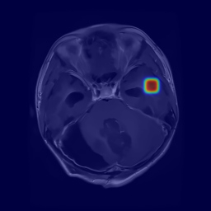

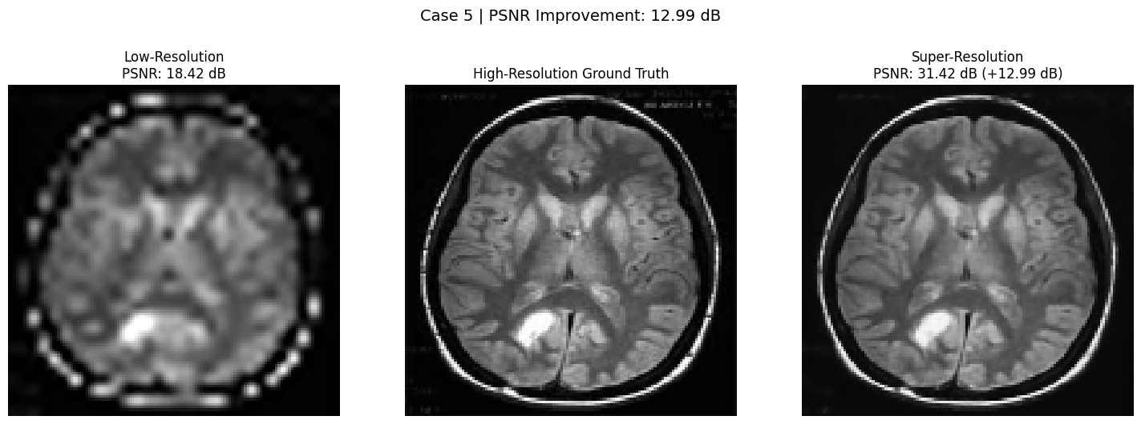

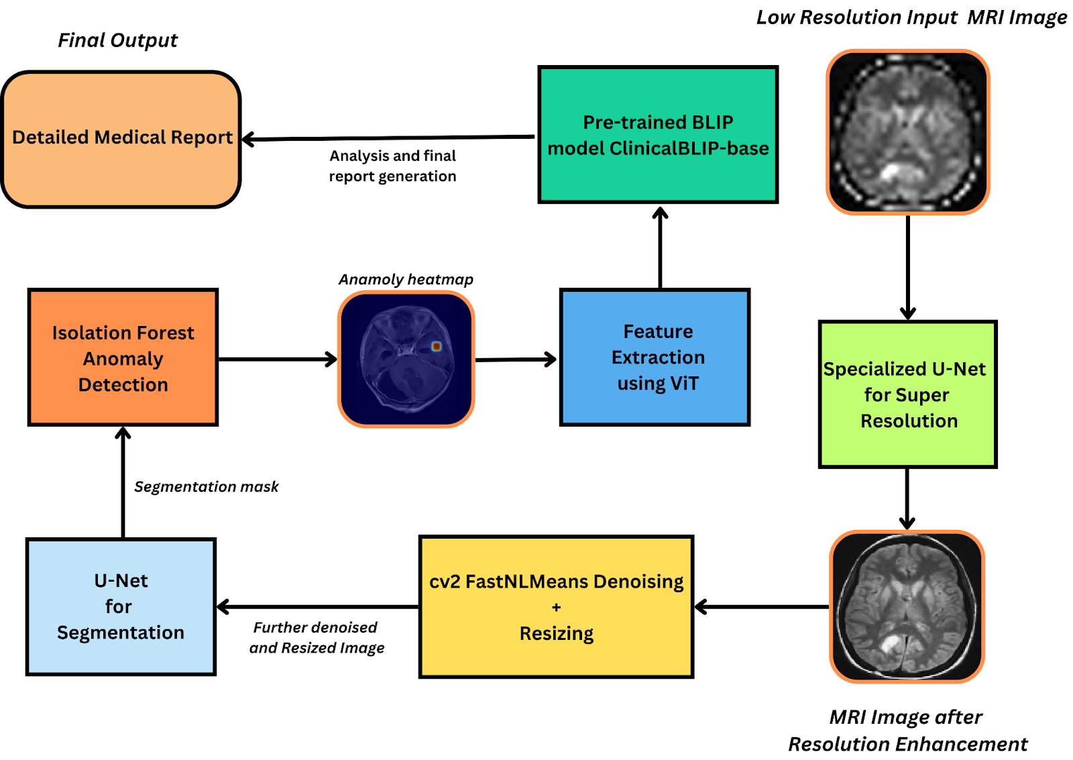Fig: the Model Architecture



*School of Computer Engineering, KIIT, BBSR* 4

*NA The Medical Image Enhancement and Malignancy Segmentation System (MIEMSS)*



Chapter 4

**Implementation**

This section details the implementation of the MIEMSS project.

**4.1 Methodology OR Proposal**

The project followed a sequential methodology:

1. **Image Preprocessing**: Fast Non-Local Means Denoising was applied to reduce noise and enhance image clarity.
2. **Feature Extraction**: HOG features were extracted to capture relevant image information.
3. **Anomaly Detection**: The Isolation Forest algorithm was used to identify outlier pixels, potentially indicating malignant regions.
4. **Segmentation**: The detected outlier pixels were segmented and highlighted to visually mark the anomalies.

**4.2 Testing OR Verification Plan**

The system was tested using a set of X-ray images with known anomalies. The testing process included:

|  |  |  |  |  |
| --- | --- | --- | --- | --- |
| **Test ID** | **Test Case Title** | **Test Condition** | **System Behavior** | **Expected Result** |
| T01 | Image Loading | Load a valid X-ray image | System loads the image successfully | Image is loaded without errors |
| T02 | Denoising | Apply denoising to a noisy image | Noise is reduced, and image is clearer | Image shows reduced noise and enhanced clarity |
| T03 | Anomaly Detection | Identify anomalies in a test image | Anomalous regions are correctly marked | Anomalies are accurately detected and marked |
| T04 | Segmentation and Highlighting | Highlight detected anomalies | Anomalies are visually highlighted | Anomalies are clearly visible |

Export to Sheets



*School of Computer Engineering, KIIT, BBSR* 5

*NA The Medical Image Enhancement and Malignancy Segmentation System (MIEMSS)*





**4.3 Result Analysis OR Screenshots**

The developed system effectively denoised input X-ray images, significantly improving visual clarity and enhancing the diagnostic quality of the scans. Using the Isolation Forest algorithm, the system accurately identified and segmented regions exhibiting abnormal characteristics, which may indicate malignancies. These regions were visually emphasized using heatmaps for easier interpretation by medical professionals.

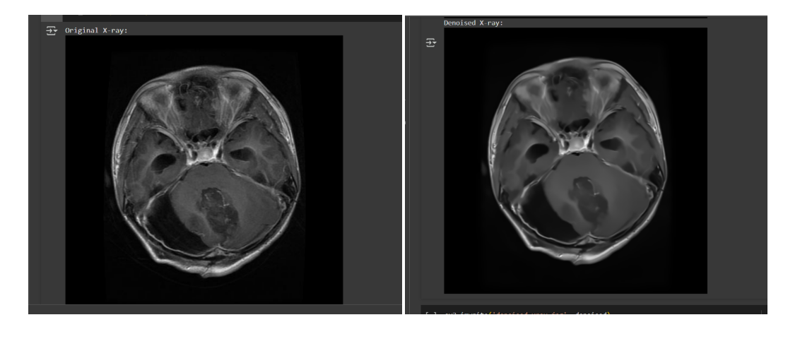

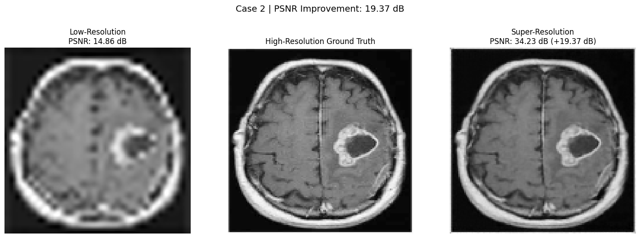



*School of Computer Engineering, KIIT, BBSR* 6

*The Medical Image Enhancement and Malignancy Segmentation System (MIEMSS)*



**4.4 Quality Assurance**

To ensure the reliability, accuracy, and maintainability of the MIEMSS system, the following quality assurance practices were implemented throughout the project lifecycle:

* *Version Control*: All project files and source code were managed using Git and GitHub to maintain history, enable collaboration, and ensure traceability.
* *Modular Code Structure*: The project was broken down into reusable and testable modules, promoting ease of debugging and future scalability.
* *Code Reviews*: Team members conducted mutual code reviews to maintain coding standards, reduce logical errors, and encourage knowledge sharing.
* *Performance Benchmarking*: Metrics such as PSNR, Dice Coefficient, and IOU were regularly measured to monitor image quality and model accuracy
* *Dataset Verification*: The input medical images were pre-verified for consistency in format, resolution, and content before training and testing.
* *Testing on Diverse Data*: The system was tested on a variety of X-ray images to evaluate generalization and robustness across different cases.
* *Visual Inspection*: Final outputs were visually analyzed to ensure the correct localization of anomalies using segmentation masks and heatmaps.
* *Backup and Redundancy:* Regular backups were maintained to prevent data loss and support recovery in case of hardware or software failure.



*School of Computer Engineering, KIIT, BBSR* 7

*The Medical Image Enhancement and Malignancy Segmentation System (MIEMSS)* 



Chapter 5

**Standards Adopted**

**5.1 Design Standards**

The architectural and workflow modeling of the system adhered **to** Unified Modeling Language (UML) standards. This facilitated a clear, structured visualization of components, data flow, and module interactions

**5.2 Coding Standards**

The implementation followed standard software engineering best practices:

* **Clear and Descriptive Naming:** Variables, functions, and modules were named intuitively to reflect their functionality.
* **Consistent Code Formatting:** Uniform indentation and spacing were maintained throughout the codebase for better readability.
* **Modular Code Structure:** Code was divided into reusable and logically independent functions or modules to enhance maintainability and scalability.

**5.3 Testing Standards**

The system was validated through rigorous testing protocols adhering to industry-standard practices:

* **Unit Testing**: Core modules were individually tested to verify their correctness.
* **Integration Testing**: The integration of various modules was tested to ensure smooth and accurate data flow.
* **Test Case Design**: Structured test cases were created and executed to evaluate the performance and reliability of the system under different scenarios.



*School of Computer Engineering, KIIT, BBSR* 8

*The Medical Image Enhancement and Malignancy Segmentation System (MIEMSS)*





Chapter 6

Conclusion and Future Scope

**6.1 Conclusion**

The MIEMSS project successfully showcases the integration of computer vision and unsupervised machine learning techniques to detect and localize anomalies in medical X-ray images. Through denoising, segmentation, feature extraction, and anomaly detection via Isolation Forests and Vision Transformers, the system provides an automated pipeline capable of assisting radiologists in identifying potential abnormalities. The incorporation of a BLIP-based report generation module further enhances the clinical relevance by producing interpretable diagnostic summaries. This project demonstrates the feasibility and potential impact of AI-driven tools in improving the accuracy, efficiency, and accessibility of medical diagnostics.

**6.2 Future Scope**

Future enhancements to the system could include:

Several directions can be pursued to extend and enhance the system:

* **Development of an Interactive Interface:** Integration with a user-friendly GUI or web application to facilitate real-time diagnostics and image uploads for clinical use.
* **Model Generalization and Transfer Learning:** Application of few-shot or transfer learning techniques to adapt the system for new, unseen medical conditions.
* **Support for Multi-modal Medical Imaging:** Expanding the system to handle CT scans, MRI images, or ultrasound data, enabling broader diagnostic applications.
* **Integration with Medical Databases:** Adding a backend system for secure storage, retrieval, and management of patient records and analysis results.
* **Explainability and Validation Tools:** Implementing visual explanations (e.g., Grad-CAM, SHAP) to improve transparency and build trust among medical professionals.



*School of Computer Engineering, KIIT, BBSR* 9

*The Medical Image Enhancement and Malignancy Segmentation System (MIEMSS)*





**References**

[1 ] Buades, A., Coll, B., & Morel, J. M. (2005). *A non-local algorithm for image denoising*. In 2005 IEEE Computer Society Conference on Computer Vision and Pattern Recognition (CVPR'05) (Vol. 2, pp. 60-65). IEEE.

1. Dalal, N., & Triggs, B. (2005). *Histograms of oriented gradients for human detection*. In 2005 IEEE Computer Society Conference on Computer Vision and Pattern Recognition (CVPR'05) (Vol. 1, pp. 886-893). IEEE.
2. Ronneberger, O., Fischer, P., & Brox, T. (2015). *U-Net: Convolutional networks for biomedical image segmentation*. In International Conference on Medical image computing and computer-assisted intervention (pp. 234-241). Springer
3. Dosovitskiy, A., et al. (2021). *An Image is Worth 16x16 Words: Transformers for Image Recognition at Scale*. In ICLR 2021.
4. Pedregosa, F., et al. (2011). *Scikit-learn: Machine learning in Python*. Journal of Machine Learning Research, 12, 2825–2830.
5. Li, J., et al. (2022). *BLIP: Bootstrapping Language-Image Pre-training for Unified Vision-Language Understanding and Generation*. arXiv preprint arXiv:2201.12086.

[7] Abadi, M., et al. (2016). *TensorFlow: A system for large-scale machine learning*. In 12th USENIX Symposium on Operating Systems Design and Implementation (OSDI 16) (pp. 265–283).

*School of Computer Engineering, KIIT, BBSR* 10

*The Medical Image Enhancement and Malignancy Segmentation System (MIEMSS)*





**The Medical Image Enhancement and Malignancy Segmentation System (MIEMSS)**

**SOHAM DUTTA**

22052064

**Abstract:** My core responsibility was the integration of Vision Transformers (ViT) for heatmap-based anomaly localization and the BLIP model for automated medical report generation. I worked on extracting spatial attention maps using ViT and used the highlighted heatmaps to guide clinical feature localization in the images.

**Individual contribution and findings:** I also integrated Hugging Face's BLIP and Clinical-BLIP models to convert detected features into natural language diagnostic reports. My work included data preparation, formatting outputs, and testing different prompt templates to optimize medical relevance and coherence of generated reports.

I gained insights into transformer architectures, prompt engineering, and practical challenges of applying text-generation models to medical data. Working with ViT and BLIP helped me understand modern explainable AI techniques and how multi-model deep learning models operate in real-world healthcare applications.

**Individual contribution to project report preparation:** I contributed the following sections to the report:

* Chapter 2: Literature Review
* Chapter 3: Problem Statements and Planning
* Chapter 5: Standards Adopted
* Chapter 6: Conclusion

**Individual contribution for project presentation and demonstration:** I prepared and presented the part on Vision Transformers, BLIP model, and report generation. I handled the technical explanation of how ViT features are converted to coordinates and how those are passed to BLIP for textual outputs. I also managed the live demo of the report generation pipeline.

Full Signature of Supervisor: Full signature of the student:

……………………………. ……………………………..



*School of Computer Engineering, KIIT, BBSR* 11

*The Medical Image Enhancement and Malignancy Segmentation System (MIEMSS)*



**The Medical Image Enhancement and Malignancy Segmentation System (MIEMSS)**

**SAYANDEEP KANRAR**

22053357

**Abstract:** In this project, my primary responsibility was the preprocessing and segmentation of X-ray images, followed by the implementation of feature extraction and anomaly detection models. I worked on applying denoising techniques using OpenCV’s fastNlMeansDenoising, analyzing the effect of different parameters on image quality. The performance was validated using PSNR values to ensure optimal denoising before further processing.

**Individual contribution and findings:** Additionally, I implemented Histogram of Oriented Gradients (HOG) for traditional feature extraction and worked on tuning Isolation Forest for pixel-based anomaly scoring. I also handled the mask generation and Dice Coefficient/IOU metric calculation for evaluation. Through experimentation and visualization of heatmaps, I localized anomaly regions and tuned detection thresholds.

While implementing this, I learned a lot about unsupervised anomaly detection, how image masks correlate with feature intensities, and gained hands-on experience working with Python libraries like OpenCV, Scikit-learn, and TensorFlow. I also explored the challenges of working without labeled data and developed strategies to overcome them using pixel-based approaches.

**Individual contribution to project report preparation:** I was responsible for drafting the following parts of the group report:

* Chapter 1: Introduction
* Chapter 4: Implementation (Preprocessing, HOG, and Isolation Forest)
* Chapter 6: Future Scope
* Chapter 7: References

**Individual contribution for project presentation and demonstration:** In the project demonstration, I presented the preprocessing and anomaly detection pipeline. I created the visualizations, heatmaps, and explained how the Isolation Forest works. I was also responsible for the slides explaining HOG and evaluation metrics.

Full Signature of Supervisor: Full signature of the student:

……………………………. ……………………………..



*School of Computer Engineering, KIIT, BBSR* 12

*The Medical Image Enhancement and Malignancy Segmentation System (MIEMSS)*



Plagiarism Report

